**Mobile app report**

**XingLiu**

1. **App description:**

This app is to help people choose cosmetics.

1. **Human interface guidelines:**

According to the human interface guideline, I follow these rules:

* 1. Visual design:
     1. Layout: this app has auto layout to Adapt to different screen sizes.
     2. Margin: this app has adequate margins and spacing around content and has readability margins when displaying text on larger devices. I set 50px in minimum on both left and right sides.
     3. Button icon(submit): The size of the submit Button for tap is 100*45, which is more than 44*44(which is the Minimum requirements).
     4. Color: using the different color for interactive and noninteractive elements. I only use grey background under button. And different color for different kinds of text.
     5. Typography: use default-system fonts to the whole app, except the title: cosmetic helping, in order to be legible. I also give font weight, size, and color to highlight the most important information in your app.
  2. Views:
     1. Image views: all in the app are consistently sized.
  3. Icon & image:
     1. Use 3x for 8 plus
  4. Controls:
     1. Picker: Arrange the types of cosmetic in alphabetical order, which is eye cream, foundation, lipstick, perfume, sunscreen.
     2. There are no switching screens to show a picker.

1. **Screen shots:**

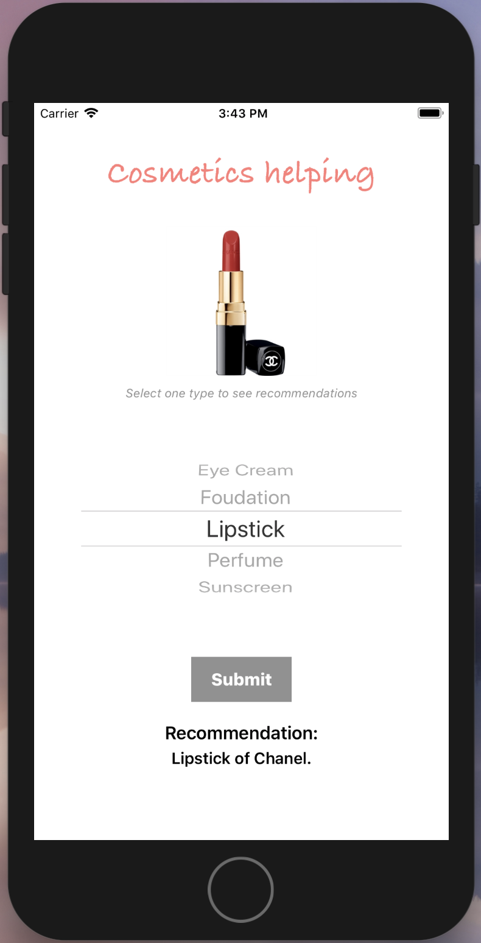

Result Page

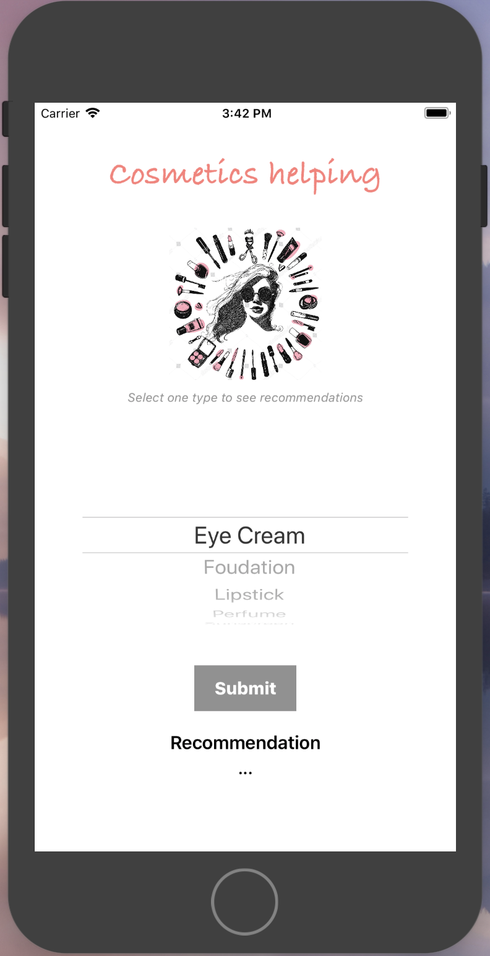

Launching Page

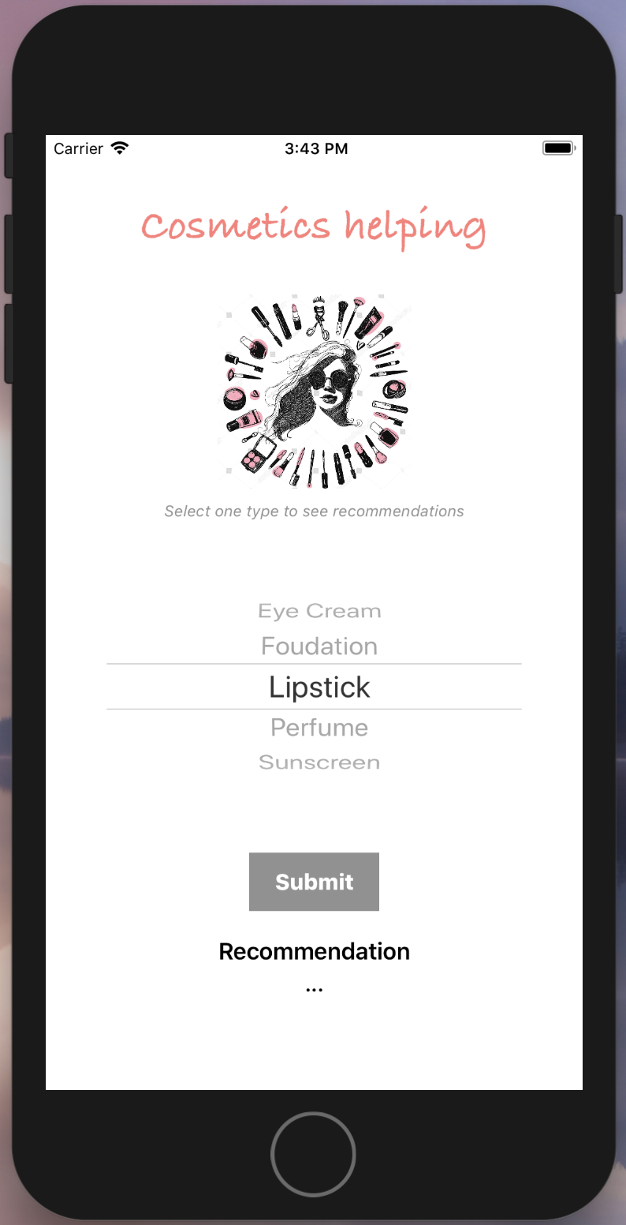

Select Page

Select page

Result page

1. **Logic flow/storyboard:**
   1. Once the users open this app, they are required to select one type of the cosmetics.
   2. After that, they have to press the “submit” button.
   3. Finally, the recommendation of brand for that particular type will show up at the bottom of the screen (randomly generate a brand from database). At the same time, the image for that cosmetic will show up in the above middle of the screen (see the image attached below).

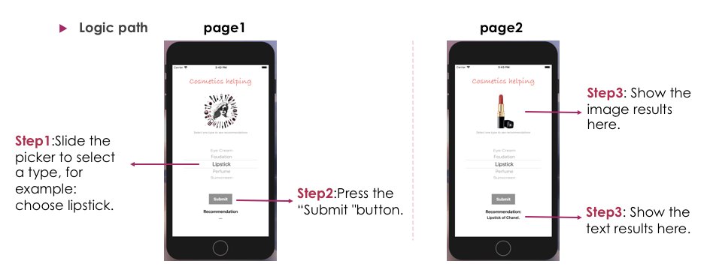

1. **Features:**

In class, we only learnt how to random number. However, in this app, I random the brands of cosmetics with displaying the corresponding picture of the product.

1. **Implementation issues:**

**Issue1: Randomize the brands.**

**Solution:**

* + - 1. Use index number (var:indexb) to present the number of brand.
      2. Use” indexB = Int(arc4random_uniform(3))” to have the random brand

**Issue2:** **Associate pictures with corresponding cosmetics.**

**Solution:**

1. Use index number (var:indexP) to present the name of the picture.
2. And then, use index number (var:indexT, var: indexB) to present the sequence for the two arrays (types and brands) .
3. After that, write an equation (indexP = 3 * indexT + indexB) for the calculation in order to connect the number of cosmetic with the corresponding picture.